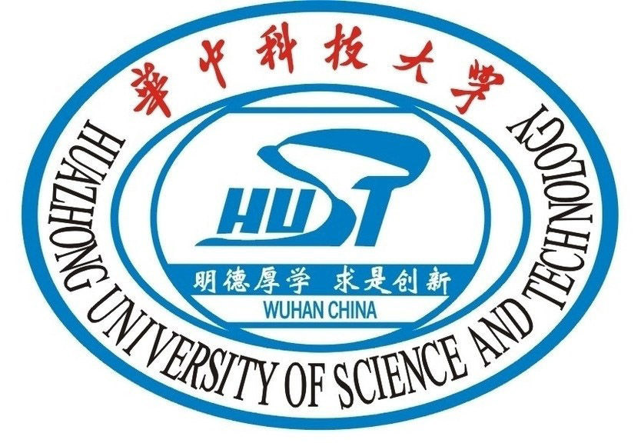
华中科技大学外国留学生(研究生)先进个人申请审批表
Application Form- HUST Outstanding International Student (Postgraduate)

姓名  Passport Name |  | 国籍  Nationality |  | 性别  Gender |  | 学号  Student ID
院系  School/Dept. |  |  |  | 专业  Major
学生类别  Categories  of Student | □ 硕士生Master’s Degree Candidate  □ 博士生Doctoral Degree Candidate |  |  | 出生日期  Date of Birth
申请类别Application Category | - 学业优秀奖 Academic Excellence Award  - 优秀学生干部 Outstanding Student Cadre  - 优秀志愿者 Outstanding Volunteer  - 优秀留华毕业生 Honorable International Graduate
个人资格  Student Qualification | □ B类以上期刊发表文章Published Paper on top journal (B level and above) 数量Quantity:  □ 校级以上奖励 Received University/Provincial/National Award  □ 促进学校与其他机构的教育交流合作 Promoted education exchanges and cooperation between HUST and other institute/country  □ 毕业论文获得校级以上优秀论文荣誉 Awarded as university/provincial/national excellent graduation thesis holder  □ 成绩良好，加权平均分(百分制) GPA（hundred percentage point）：  □ 在校表现良好，无违纪违法行为 None against discipline/regulation/law record  □ 其他 Others:  签字(Signature)： 日期(Date)：
导师推荐意见  Recommendation  By  Supervisor | 签字(Signature)： 日期(Date)：
学院审核意见  Evaluation  By  School/Department | 签章(Seal)： 日期(Date)：
国际教育学院  审核意见  Decision by School of International Education | 签章(Seal)： 日期(Date)：
申请人应同时提交如下支撑资料Supporting materials should be attached as follows；
1. 原始成绩单Academic transcript; 2. 发表的高水平论文 Papers published on Top Journals (B level and above);
3. 获得的奖励证书Reward Certificate; 4. 其他材料Other supporting materials.

