2020 new international students online appointment instructions
Web link: http://admission.hust.edu.cn/apply
Login account and password: application account

1. Confirmation information
1). After the student logs in to the system, the personal information as shown in the figure was determined according to the original application information. If the information is wrong which can’t be corrected right now, please tick the box, if the information is right, please DO NOT tick the box.
As shown below
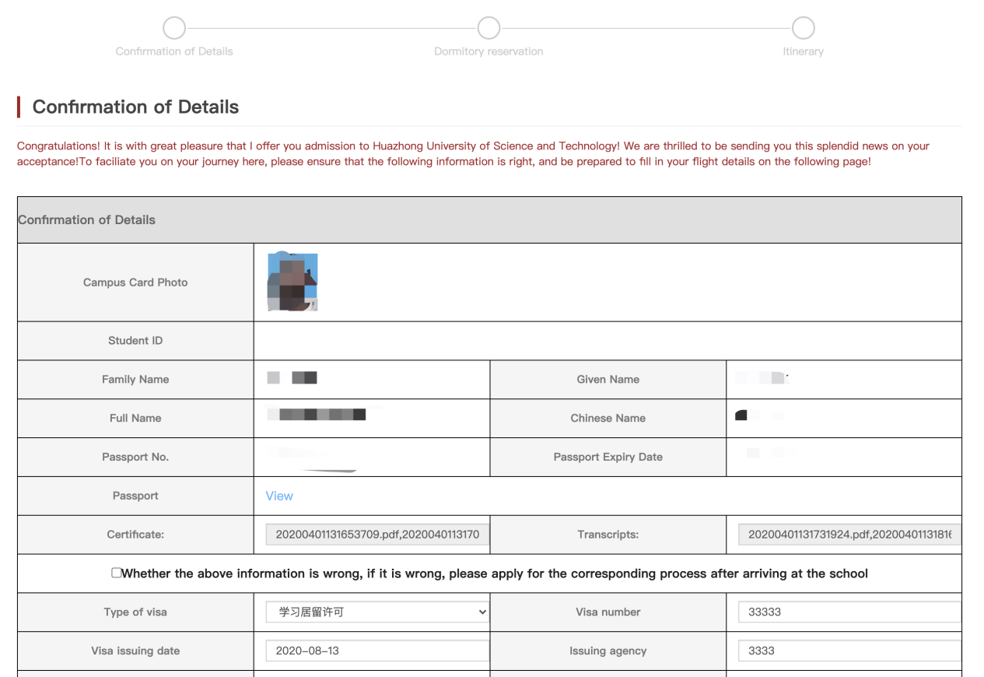
图1.1
2). As shown in the figure below, fill in the personal visa information and upload the scanned document of the visa. If you have any accompanying persons, please add relevant information about the accompanying persons.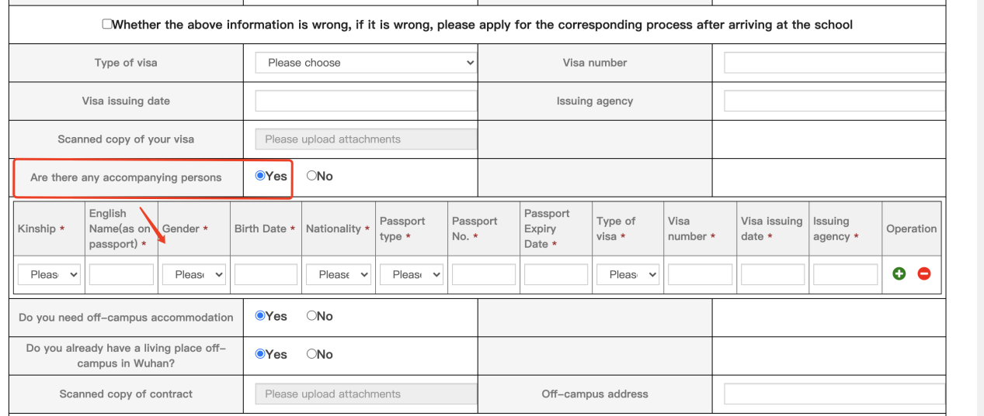
图2.1

3). Those who need to live off campus and have already checked in off campus in Wuhan, please upload a scanned copy of the rental contract and fill the rental address in Chinese.
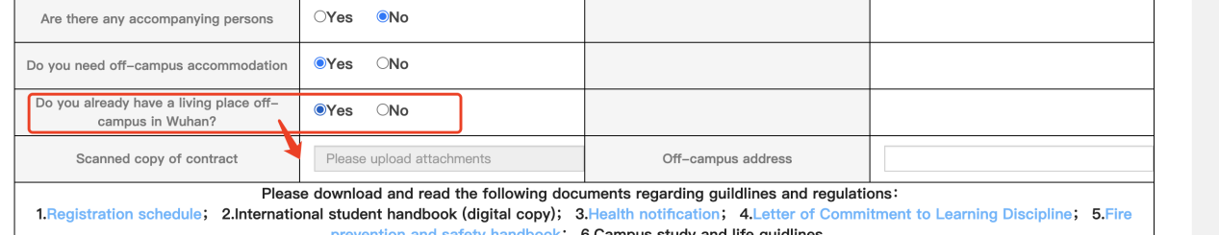
图3.1
3. Download the documents regarding to the regulations and guild lines in the university. Upload a scanned copy of personal signature (the background color is white)
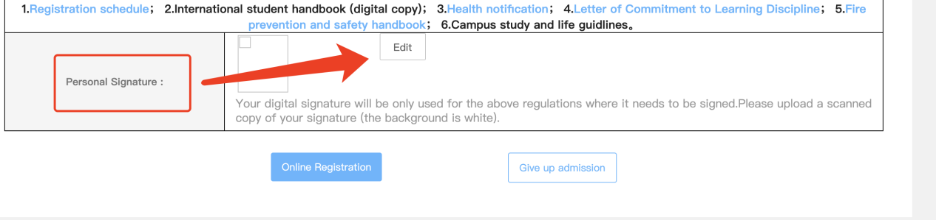
图4.1
2、Dormitory reservation
1. Choose your own suitable dormitory according to the occupancy situation of the dormitory, first choose the apartment you want to live in
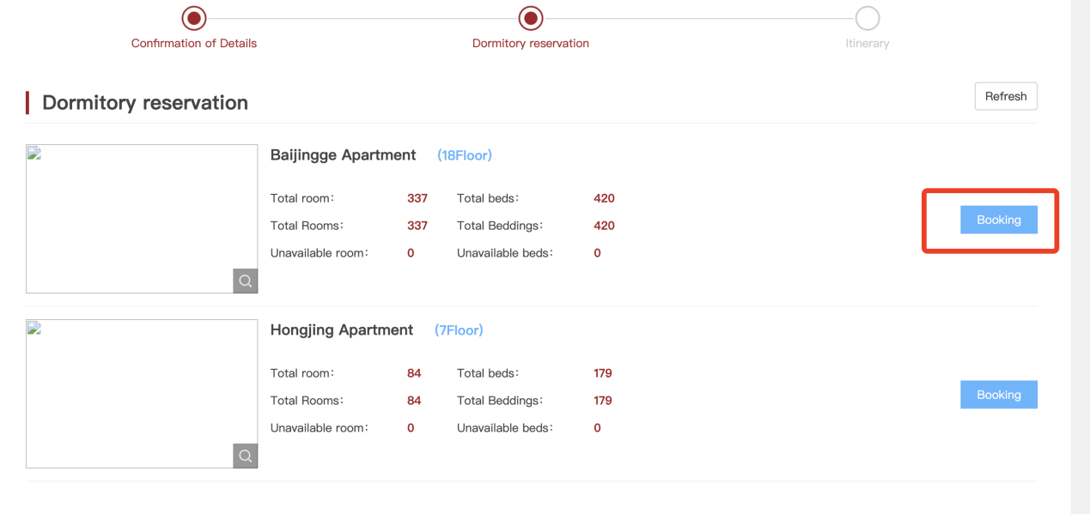
2. Then select the type of room (such as single room, double room, etc.)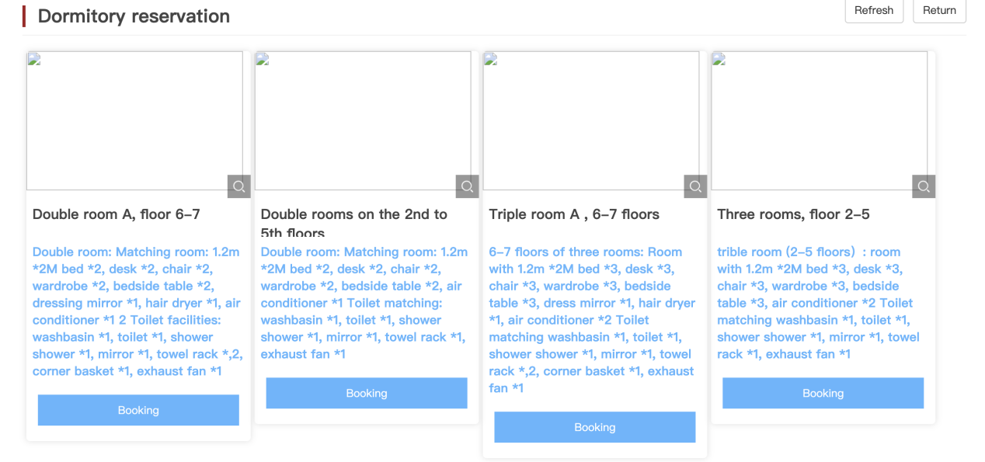
3. Finally choose the room to stay in

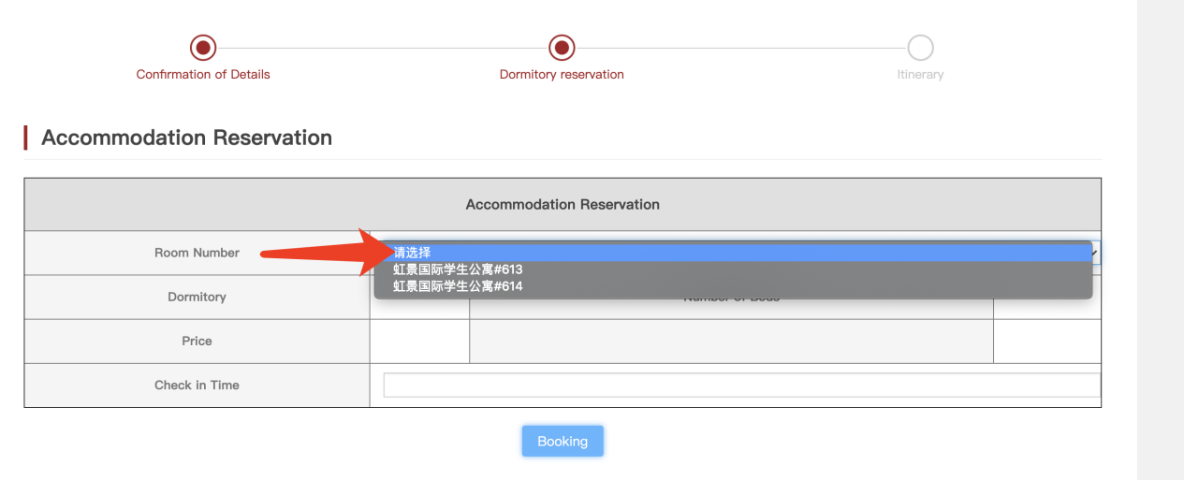

3. Pick up reservation
Fill in the flight/train information for pick-up
Note: Students who come by their own to university may not be allowed into campus, please arrange your travel according to the pick-up service available. The pick-up services available are as in the following:
Wuhan Tianhe airport: Sept. 14- 16, Morning 11am, Afternoon 4pm, Evening 9pm
Hankou train station: Sept. 14- 16, Morning 8am, Morning 11am, Afternoon 2pm,Afternoon 5pm, Evening 7pm, Evening 9pm
Wuhan train station: Sept. 14- 16, Morning 8am, Morning 11am, Afternoon 2pm,Afternoon 5pm, Evening 7pm, Evening 9pm
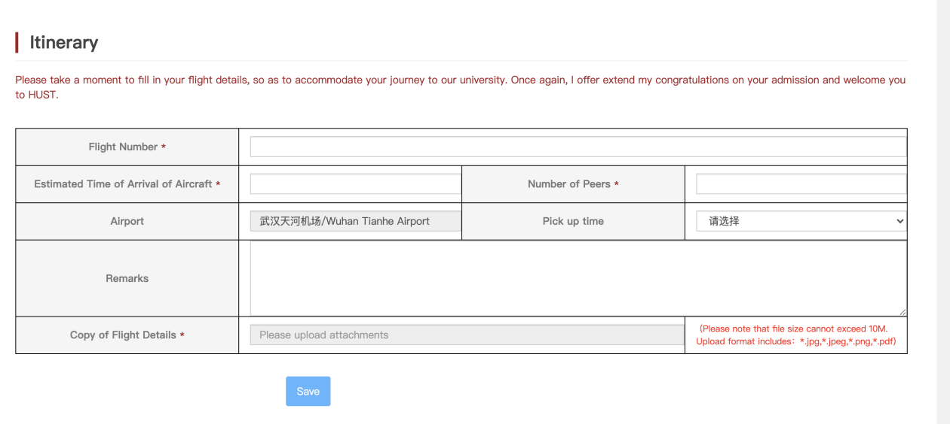
4. View and modify submitted information
After online registration is completed, you can view the previous basic information and accommodation reservation which are not allowed to edit and change the pick-up information.
